Evolve Environmental Solutions is an award-winning environmental landscaping and natural areas rehabilitation company.

Our commitment to ensure we provide a consistently high standard of administration, management and construction service to our clients, approving authorities, and the general community.

To ensure client satisfaction we will: -
- commit adequate resources and competent personnel to our projects; and
- have an implemented Quality Management System.

Evolve Environmental Solutions is committed to:

- Maintaining high standards of honest, ethical and legal business behavior at all times
- Providing our customers, investors, suppliers and business partners with an experience that delivers excellence, meets or exceeds expectations of quality performance and engenders loyalty
- Engaging with our suppliers to improve consistency of their delivery skills
- Developing, recognizing and rewarding our staff to facilitate optimal performance, achieve career objectives and foster a high-performance culture
- Continually improve our performance to create “best in class” in delivery
- To promote the use of innovative solutions, technologies and construction methods
- To take actions to address risks and opportunities which could impact on the delivery of our products and services
- To ensure the needs and expectations of interested parties are included in our risk and opportunity process
- Regularly reviewing our policies and procedures to ensure compliance with legislation and ongoing relevance

Evolve Environmental Solutions Quality Management System establishes the framework to achieve our quality objectives through measurable targets, quality plans, procedures and the empowerment of personnel through accountability and training.

Accountability

I commit Evolve Environmental Solutions to the implementation of this policy and task all personnel across Evolve Environmental Solutions with contributing to this goal.
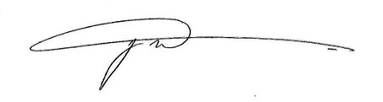

Jason McGarry
Managing Director

