Evolve Environmental Solutions is an award-winning environmental landscaping and natural areas rehabilitation company. Our commitment to the Environment and Sustainability is out come based, innovative and founded on the belief that we have a wider responsibility for our contribution to have a lasting impact. Sustainability is about creating a lasting legacy for the planet and for our people. Evolve Environmental Solutions recognizes that acting in a responsible and sustainable manner creates new opportunities, enhances investor value and improves social and environmental returns.

Objectives for achieving our vision

- Having an implemented Environmental Management System.
- Establishing measurable objectives and targets aimed at the elimination of environmental impacts from our activities, products and services
- Defining roles, responsibilities and levels of accountability

Commitments

- Integrating risk management principles in all core planning activities; including the prevention of pollution
- Maintaining high standards of honest, ethical and legal business behavior at all times
- Engaging with our suppliers to improve the sustainability performance of our supply chain
- Providing sufficient resources to ensure compliance remains central to core business values
- Enhancing the communities in which we operate through actions including active engagement, offering innovative and sustainable products, preserving heritage and enhancing culture and a focused program of community contributions, investments and initiatives
- Developing, recognising and rewarding our staff to facilitate optimal performance, achieve career objectives and foster a high-performance culture committed to sustainability
- Improving resource efficiency and minimising the environmental impacts of activities, including the prevention of pollution
- Positioning Evolve Environmental Solutions to operate in a changing climate and carbon constrained economy
- Pursuing continual improvement in corporate responsibility and sustainability management and performance
- Regularly reviewing our policies and procedures to ensure compliance with legislation and ongoing relevance

Accountability

I commit Evolve Environmental Solutions to the implementation of this policy and task all personnel across Evolve Environmental Solutions with contributing to this goal.
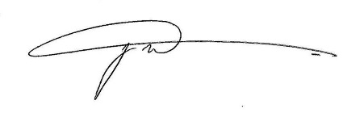

Jason McGarry
Managing Director

